
Authorization Agreement for Accounts Payable Automatic Deposits
(Automated Clearing House Credits/Debits)

I hereby authorize Centerplate, Inc dba Sodexo Live!., hereinafter called COMPANY, to initiate credit entries, and if necessary, to initiate debit entries and adjustments for any credit entries in error to the account(s) indicated below, and the depository, hereinafter called DEPOSITORY, to credit and/or debit the same such account.

This authority is to remain in full force and in effect until COMPANY has received written notification from me of its termination in such time and such manner as to afford COMPANY and DEPOSITORY a reasonable opportunity to act on it.

Name
(Please Print)

I am Beginning Automatic Deposit
Changing Account information (i.e. account #)

Employee Vendor #
(The number in the upper left corner of your expense report. Not your Lawson #)

Account: Checking Savings

ABA* Check Routing Number

Account Number

Bank (Depository) Name

Branch Address

Bank Phone Number

Email Address for Acknowledgement

Signature Date

SAMPLE ABA AND ACCOUNT NUMBER INFORMATION

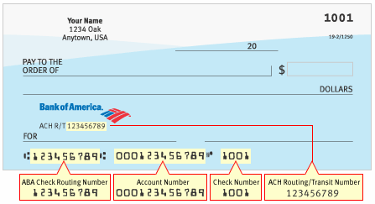

Please call your bank account representative to verify your Transit/ABA (Routing) number and account number if you are uncertain.

With your checking account, please do not get these numbers from the deposit slip, use the check. Some banks, like Wells Fargo, use different numbers.

